* **Before Logging In**

**(Everything in this Document is line wise, so go by page to page heading to heading wisely)**

**Page: Desktop1**

1. Delete the logo in below picture.

1. Rename “de Service” to Services

1. Rename “de Nous” to Nous

1. Rename “Contactez” to Contact

1. Delete these both picture points from main page that are commented (in below picture)

1. Rename this small heading box in below picture to “la communaute btob job”

1. Insert the “B to B Job Solutions Pro” logo here in the place of or before Services title

1. Align the Logo correctly here

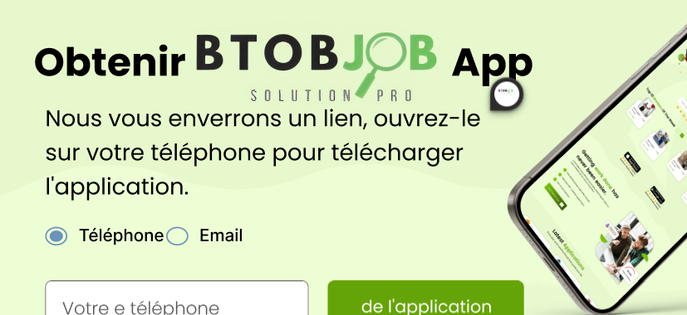

1. Replace the following picture mentioned phrase to “Trouves le professionel dont tu as besoin !”

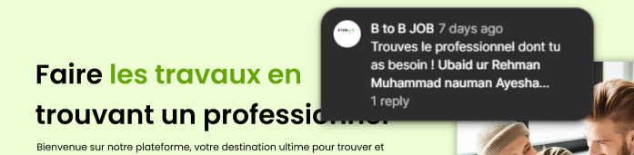

1. Replace the following picture’s button box name to “se connecter”

1. Replace the following phrase to “Trouver le professionel”

1. Replace the button name “se connecter”

1. Rename this button to “Proposez vos services”

1. Rename this phrase to “Trouver vos clients”

1. Delete this whole “section” of “Gerer Votre entreprise” and its below 4 points.

1. Rename this “Registre” button to “se connecter”

1. Delete the phrase “Apprendre encore plus”

1. Delete the profile pictures getting mis-aligned or out of page like in following (circled) picture (just let the middle one’s or the one’s that appearing fully there):

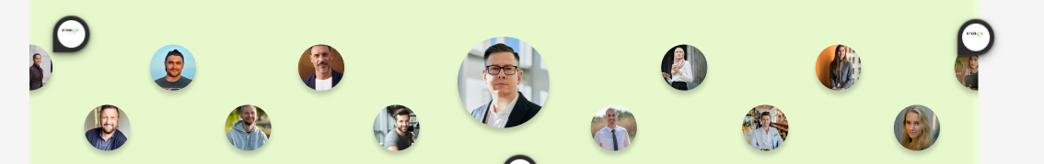



1. Insert “Facebook”, “Instagram”, “LinkedIn” socials just above the footer.

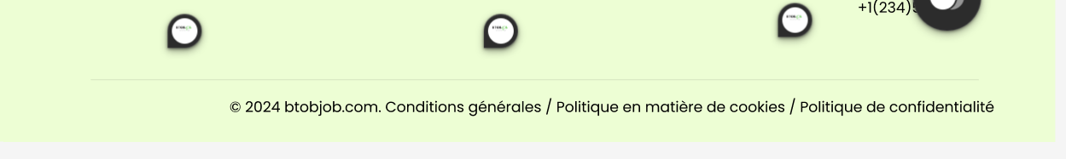

1. Delete “A propos de emploi B2B Blog**"** phrase just below “A Propos”

**(Let the other phrase be there)**

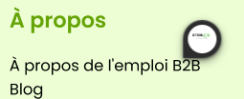

1. Replace the “Contact information” with the right info.

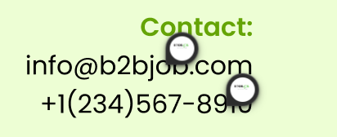

**Page: signup**

1. Replace “Individuel” with “particuliers”

**Page: Login Page**

1. Replace “Bienvenu” with “Bienvenue”

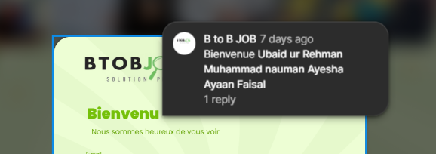

**Page: Contact Us**

1. Replace the following phrase with “Contactez-nous”

1. Delete this heading (in following picture)



1. Replace the information with correct info.

1. Replace the “Numbero” with “Numero” and set the limit of maximum 10 numbers to be opted in the blank.

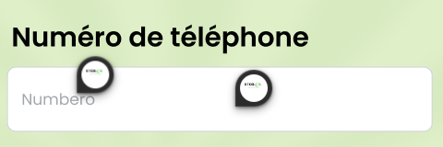

1. Replace the following phrase with “Ecrivez votre message”

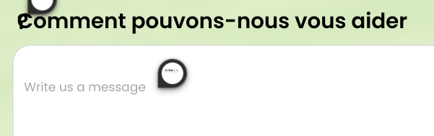

1. Replace the following phrase with “Envoie message”

1. Delete the phrase under A propos in the following picture:

**(Let other phrase be there)**

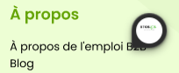

1. Replace with correct information

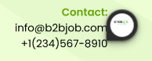

1. Ensure that the link is always: **btobjob.com**

**Page: Contact Us Submitted**

1. Translation of pointed comments (places) in the following picture:

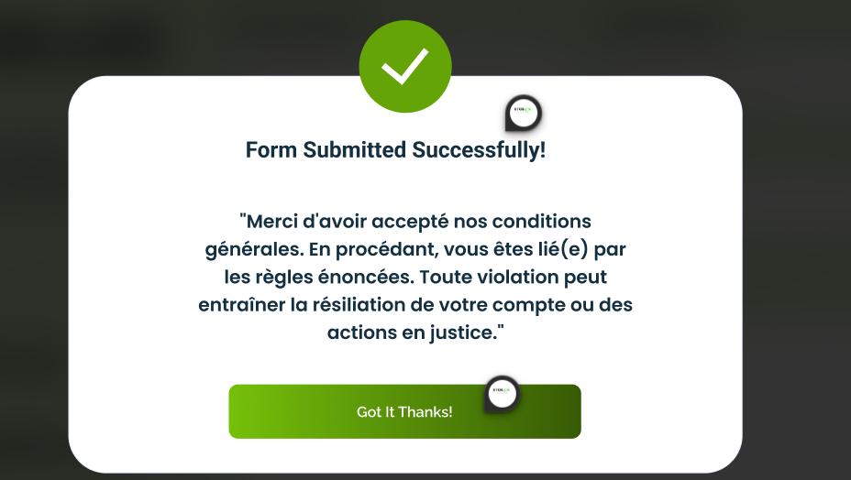



**Page: Rent Before Login**

**(ONLY PROFESSIONALS CAN ACCESS THIS PAGE – Like: Only simple and available content will be viewed, rest will blurred for people (Individuals) and they (individuals) will also not be able to Rent an item.)**

1. Delete the following part from this page:

**(This whole picture mentioned box)**

**Page: Adding an item before Login**

**(Only Subscribers can view contents of this page, rest for all it will be blurred with only some top content will be viewed but not accessible by Individual Users (Not Subscribed).**

**Page: FAQ**

1. Delete the phrase “nous vous avons” from this page:



1. Translate this phrase “Popular Topics” mentioned in the following picture:



**Page: About Us**

1. Delete the title from this page,

Secondly, insert the “B to B Job Solution Pro” Picture in the background



**Page: Subscription**

1. Delete and Replace Services provided with each subscription bought,

Delete the following mentioned subscription and replace them all by:

**particuliers gratuit forfait comprenant**

**Emplois**

**stages**

**apprentissages**

**demandes de devis**

**achat de site internet**

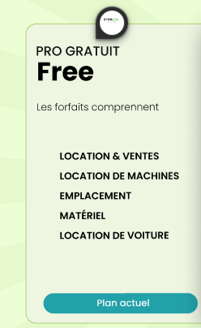

1. Delete and replace the following services provided under this subscription by:

Pro

20E TTC / MOIS

accès illimité

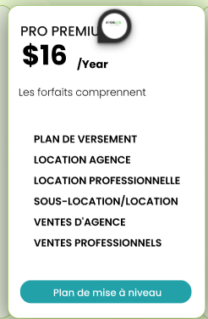

1. Delete this Subscription section:

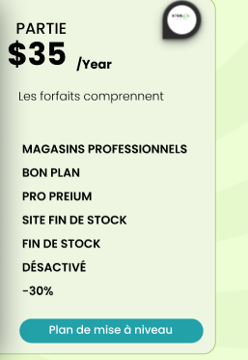

**\*\*\*(POINT TO UNDERSTAND REGARDING SUBSCRIPTION PAGE:**

**professionals have a monthly package of 20 euros it is an annual contract which is renewed every year by tacit agreement however they can pay directly for the year so as not to be deducted every month if they pay directly for a year's subscription they pay 220 euro instead of 240 euro (information for you so that you understand))\*\*\***

